Aggregate functions:

db.rajesh.aggregate([{$match : {"dept" :"CSE"}},{$count :"TOTAL STUDENTS IN CSE"}])



Max marks

db.rajesh.aggregate([{$group:{_id:"$dept",max_marks:{$max:"$marks"}}}])



Min marks

> db.rajesh.aggregate([{$group:{_id:"$dept",min_marks:{$min:"$marks"}}}])



Sorting marks

> db.rajesh.aggregate([{"$sort":{"marks":1}}]).pretty()

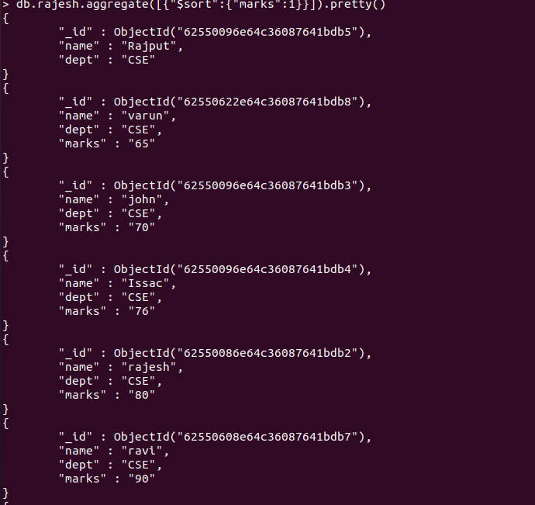

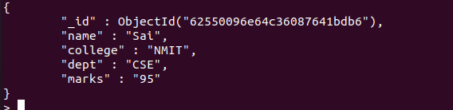

Greater than:  
 db.rajesh.aggregate([{$match:{marks:{$gt:"80"}}}]).pretty()

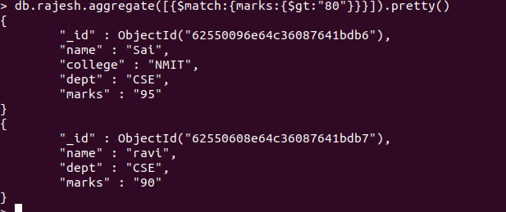

Less than:

db.rajesh.aggregate([{$match:{marks:{$lt:"80"}}}]).pretty()

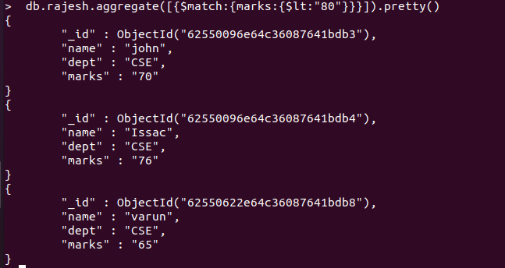

Unwind

db.rajesh.aggregate([{$unwind:"$marks"}])

